**Installation Checklist Supplemental Information**

1. **Stakes**

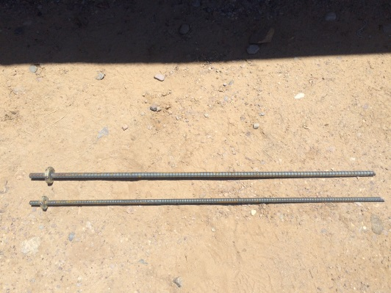 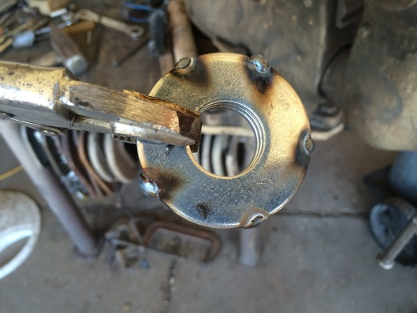

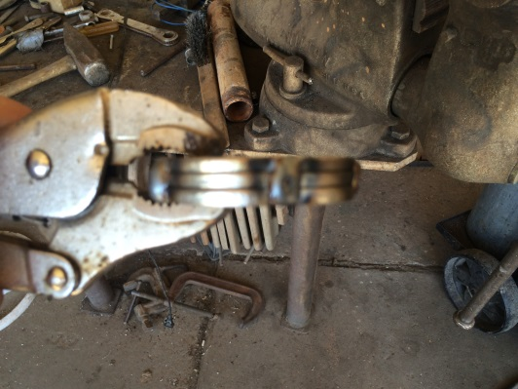 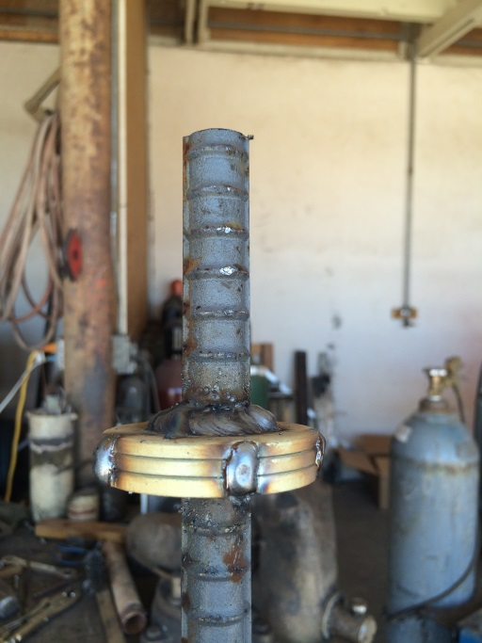

* 1. **Guy Wire Stakes** (x4)-Constructed of **5/8”** rebar cut into a **4’** piece. Tack weld **3x 7/8”** washers stacked together. Weld washer stack to rebar approximately 2” from one end. Cut angle on bottom edge of sake.
  2. **Tower Base Plate Stakes**(x5) constructed in same manner as above but with **1/2”** rebar cut to **4’**, and with **3x5/8”** Washers stacked

1. **Sensit Mount** (x1)

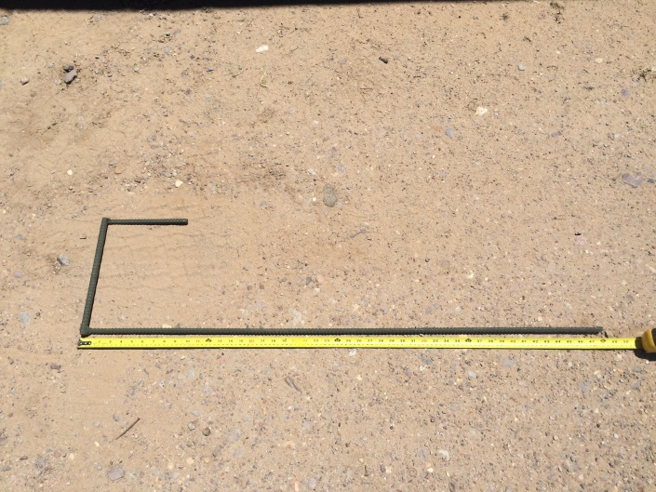 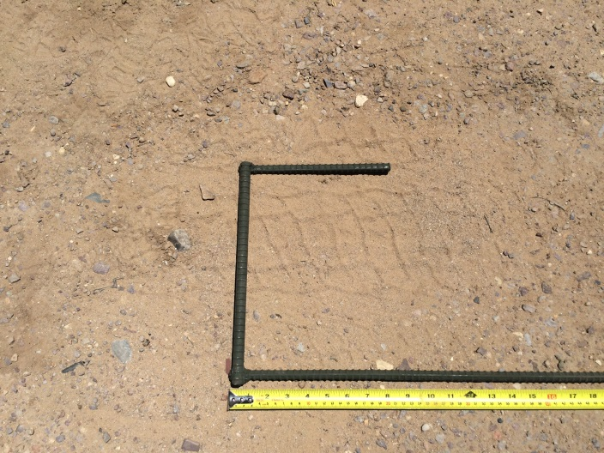

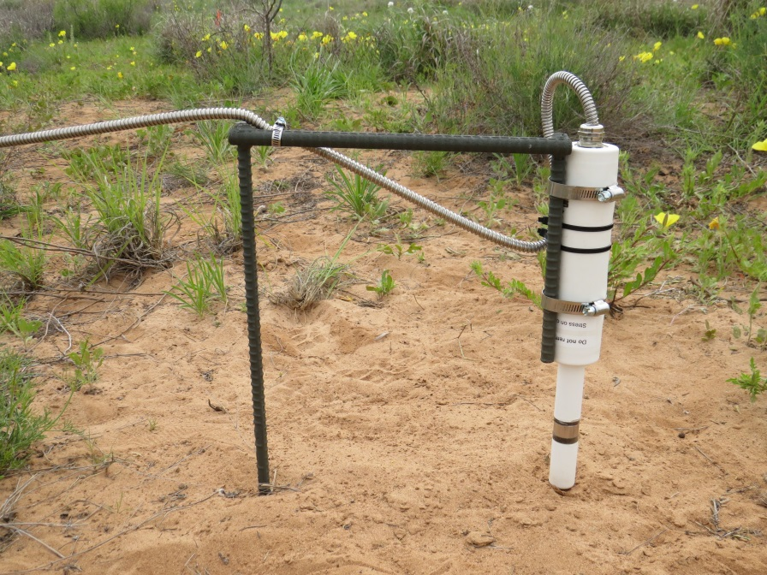

* 1. Constructed of ½” Rebar. 1x4’, 1x12”, 1x 8-1/2” pieces welded together. Paint rebar to prevent rusting.
  2. Use (2x) 1-13/16” to 2-3/4” hose clamps to attach sensit to vertical piece of rebar.
  3. Use (2x) ½” to 1-1/8” Hose Clamps to fasten sensit cable to horizontal rebar. **Not pictured**
  4. Ensure to keep a big loop in the cable where it attaches to the sensit to reduce pressure where the cable enters the sensor.

1. **MWAC Masts (x27)**

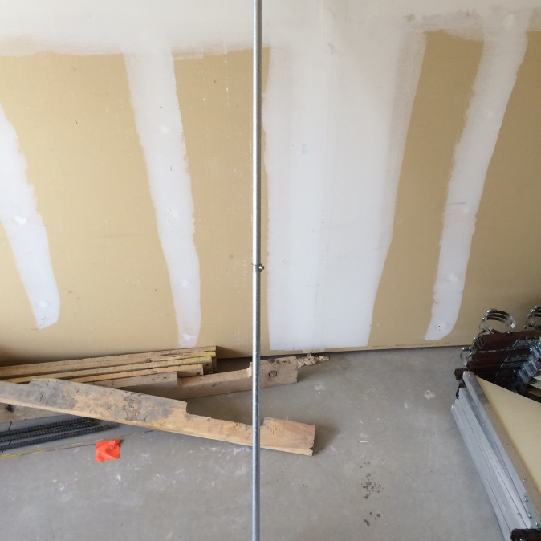 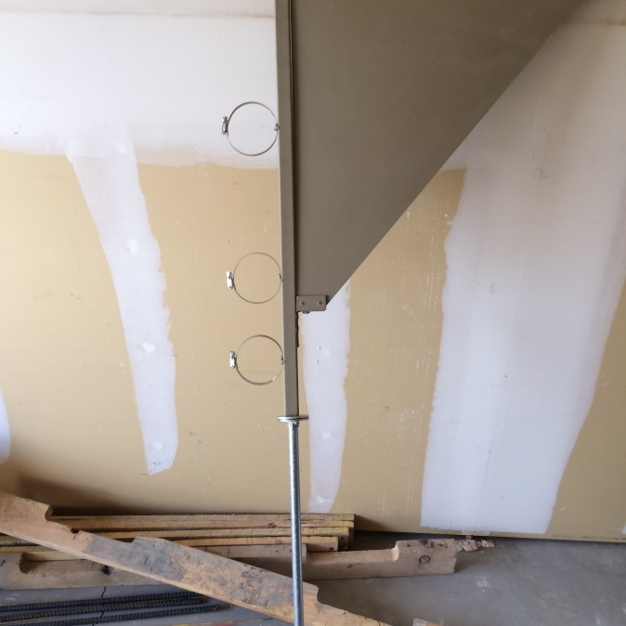

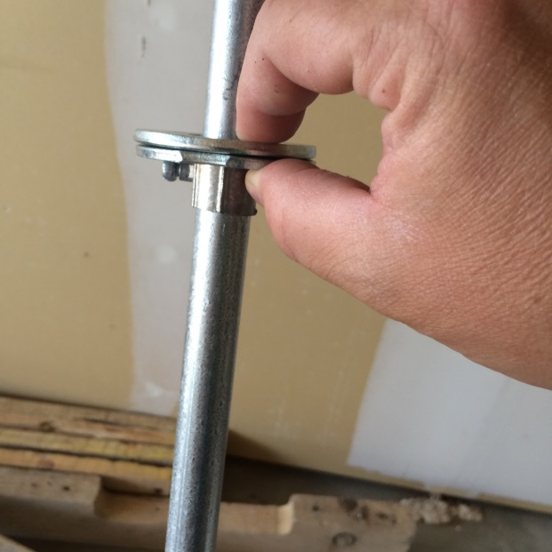 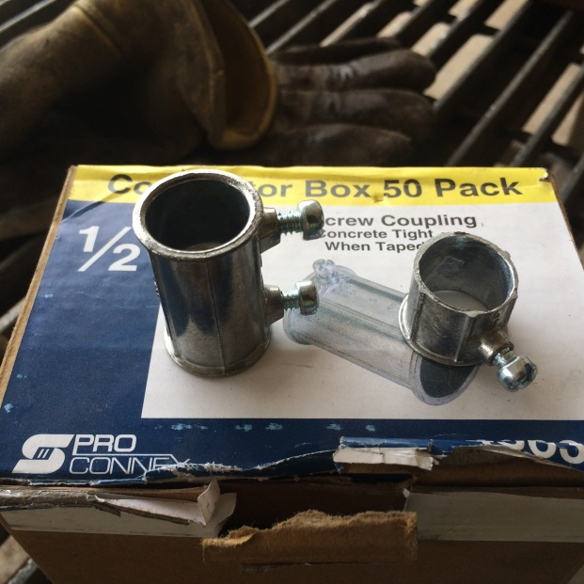

1. Constructed of 1x10’ Piece of EMT Conduit, ½ of a 2” EMT Conduit Connector, 2x7/8” Washer.
2. Cut conduit into 6’ Piece.
3. Cut 2” EMT conduit connector in half (This may require deburring of inner diameter to fit over 6’ Conduit
4. Slide connector down 6’ conduit ~30 inches and tighten set screw
5. Slide 2x7/8” Washers down on top of setscrew lip
6. Pound mast into ground with 1” between the soil surface and the bottom of the set screw coupler
7. Place fin on top of conduit and slide down to rest on washers
8. Ensure bottom bottle is 10cm above soil surface, and find is level in all directions.
9. After fins are fabricated, cut 1” of steel from the bottom of the fin so that the setscrew/washers can be fastened 1” above the soil surface on the mast. This enables the fin to pivot freely while maintaining 10cm to the first bottle

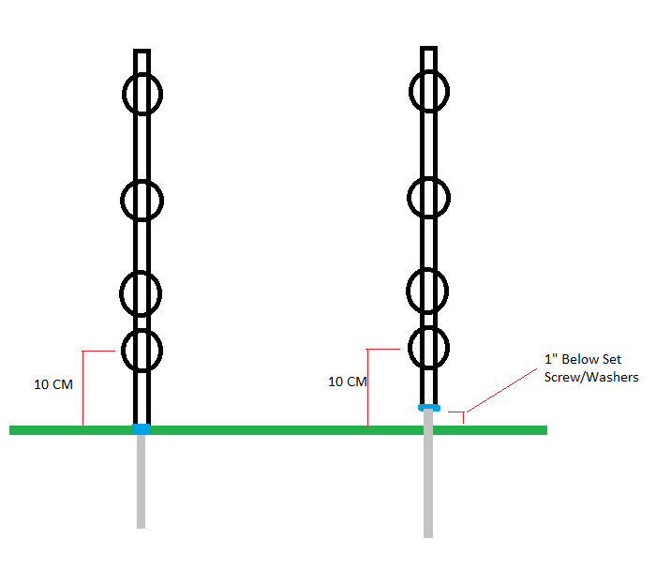

1. **Camera Mounting/Installation**

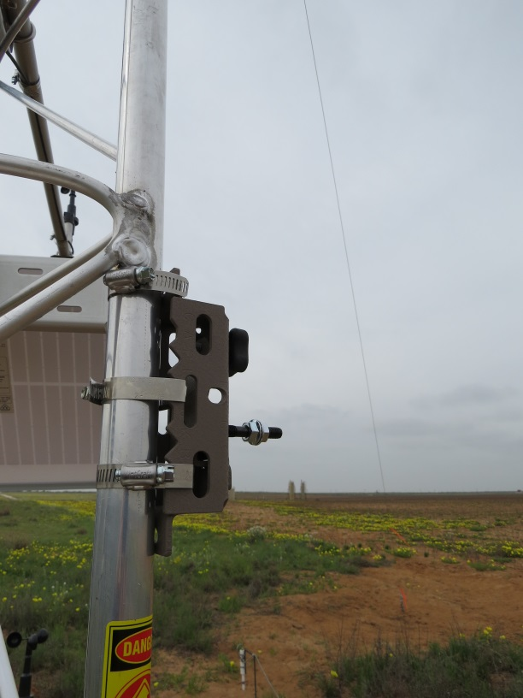 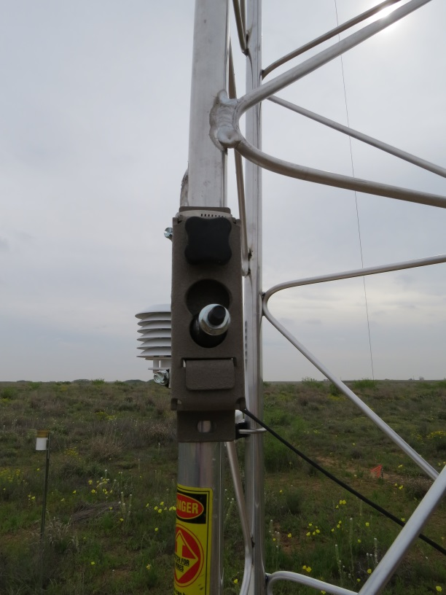

* 1. Parts Needed: Camera enclosure and mount, (3x) 1-1/16” to 2” Hose Clamps.

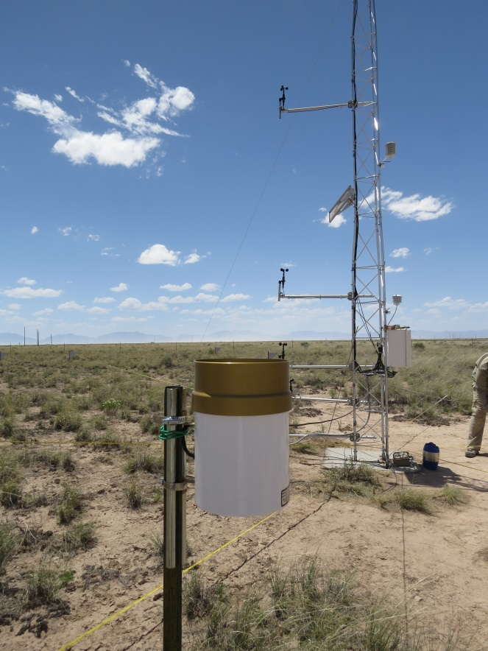

1. **Rain Gauge Mount**
   1. Equipment needed:

(1x) 6’ T-Post, (2x) 1-9/16” to 2-1/2” hose clamps, (2x) 1’ pieces of EMT conduit (use scrap form MWAC masts)

* 1. Attach EMT Conduit to T-Post and rain gauge with hose clamps.

**\*Use a 5’ Piece of EMT Conduit to support wire from Gauge to Enclosure if necessary.**

1. **Tower Foundation Installation**

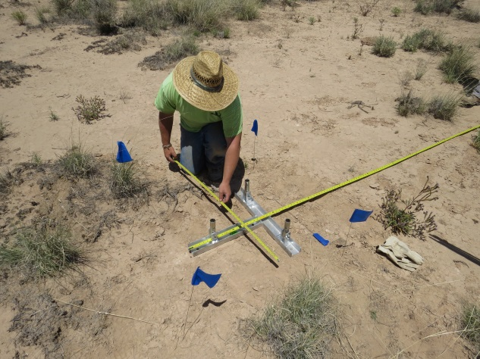 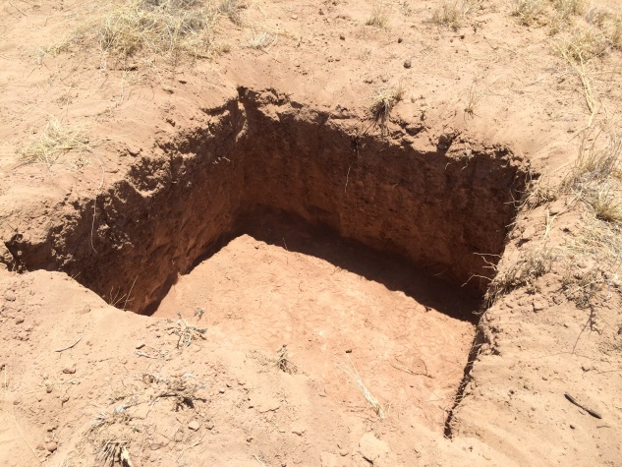

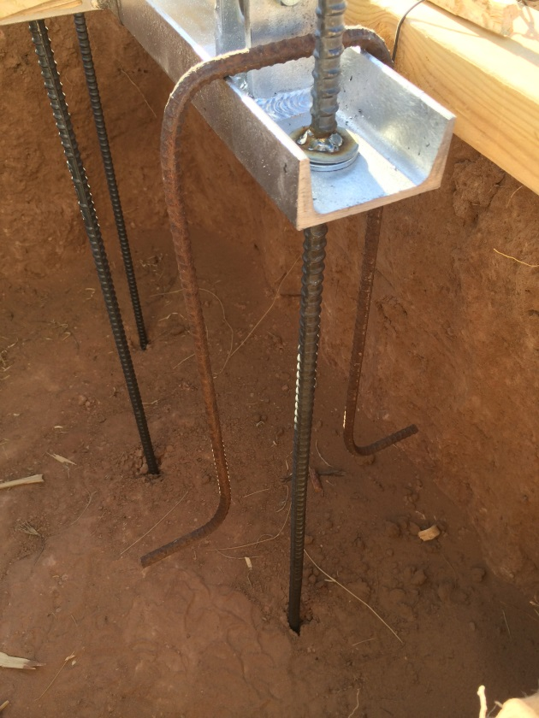 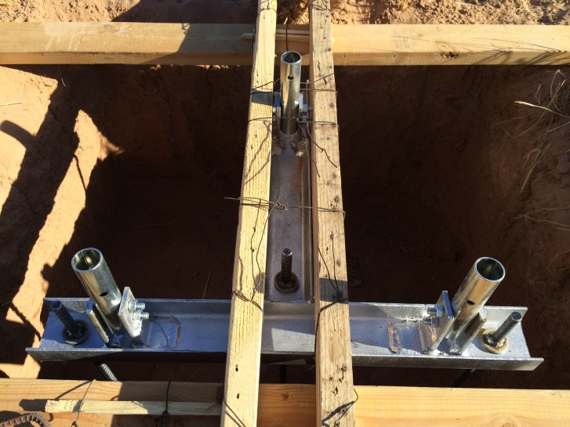

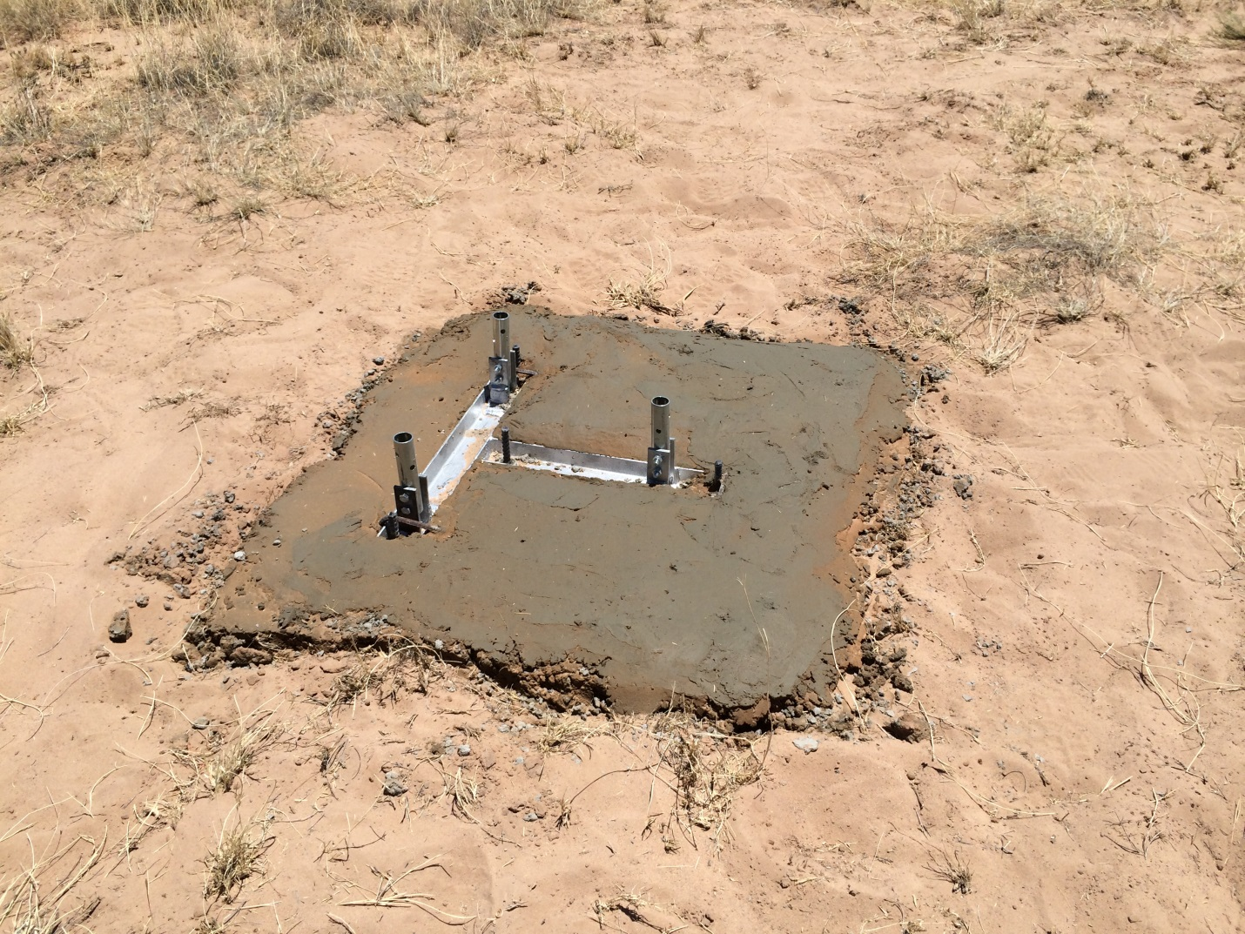

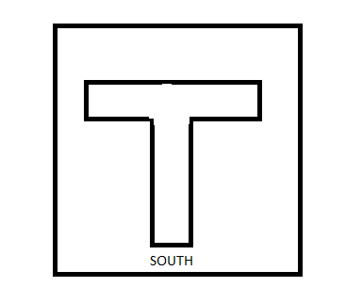a.Parts Needed: Tower Base Plate, Base Plate Stakes, Rebar loops, Wood and Wire for Jig, Level (x2). Align Base plate in hole so that it faces South

b. Install all washers, nuts, and bolts on base plate before installing ensuring bolts can be removed once stakes are in proper holes. Cover hardware with tape before placing in jig.

c. Bend ½” or ¼” Rebar to reinforce base plate in concrete foundation. Rebar was bent using a vise. Dimensions depend on depth of hole. (Pictured above) Loop over base plate and extend down to approximately 2” above bottom of hole with horizontal flared ends.

1. **Guy Wire Shackles** 
   1. Purchase shackles (1/2” Galvanized) to fasten guy wire tensioner to the guy wire stakes. This enables quick disconnect from stakes. Photos will be provided

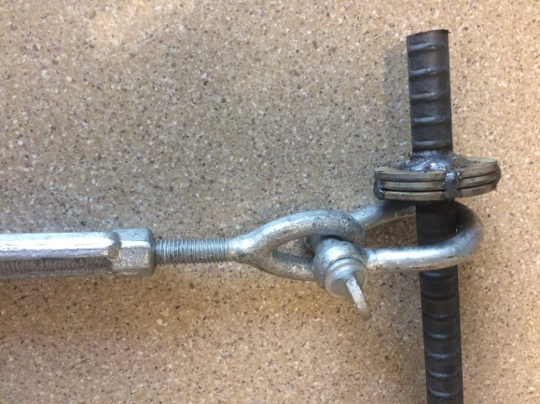 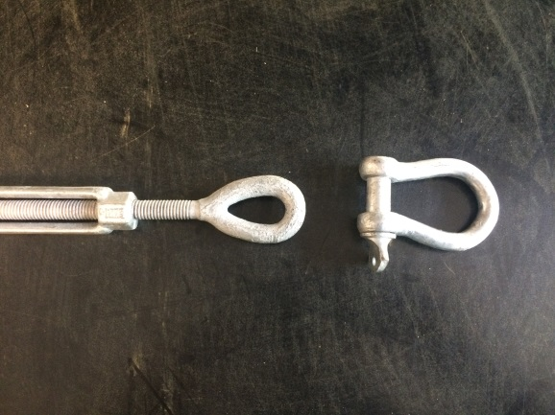

1. **MWAC Bottle Construction**
   1. Use the Hilmore lever bender to bend bottle tubing. There have been issues using other benders. <http://hilmor.com/products/lever-benders>

¾” LB34 Item # 1839029

1. **Mounting Solar Panel**

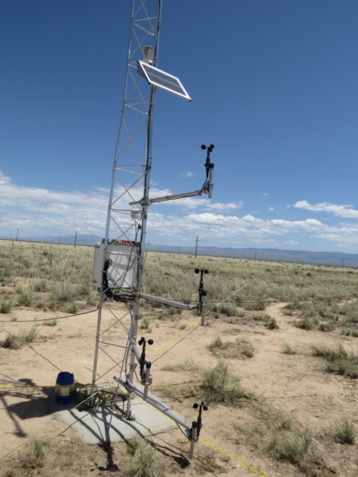

* 1. Mount Solar Panel Facing South at approximately 3.5meters on Met Tower. Refer to Campbell Manual for the proper angle based on your location.